Introduction
Welcome to using the Scanco uCT 40. This scanner is designed specifically for ex vivo samples and can achieve a minimum voxel size of 6um, which roughly translates to detecting size differences of around 13um or larger. It is the standard for ex vivo mouse bone phenotyping, especially when you have a large number of samples. If you want to scan in vivo or have a small number of samples, the VivaCT 40 is an excellent choice. If you have need to scan any materials that are not bone, there are solutions available; talk to the lab manager for how best to proceed.
When using this scanner, you absolutely must be trained by the laboratory manager, Daniel Leib, or a delegate of his choosing if required. A labmate cannot train you. He will help you determine settings for how to perform the scans and how to analyze them. It is completely inappropriate to use a control file or analysis script just because “it’s the one your lab has always used.” If you perform uCT in this manner, your results will probably be wrong. Take the time to talk to the lab manager about each specific experiment you perform, and ideally, talk to Matt Silva, Core B director, about how to plan your experiment before getting started.
This system is run on an operating system called VMS; that means there are some strange things that must be done which would be much simpler on Windows, such as copying files and compiling results. Make sure to get familiar with how to do these things by looking over this manual as well as paying close attention when being trained. Take notes!
When performing scans on the uCT 40 and also on the VivaCT 40, your sample number represents your experiment, and each measurement number represents an individual scan. It’s important to keep track of these in your notebook as you will need to reference them when doing analysis and scanning additional items for your study. If you have more than one bone in a scan, you must also use a method to make sure you know which bone is which by drawing a picture in your notes and making sure you have an asymmetrical marker to work from (we often use pieces of a toothpick).

Scheduling
Scheduling for this lab is done through iLabs. If you don’t have an iLabs account, a PI that you’re associated with (can be yourself), or an account number to bill, you can’t sign up. If you have any questions on how to set this up, contact Stephanie Simpson at simpson.s@wustl.edu. For your first visit, you absolutely must be trained by the lab manager or a due appointee; your labmate cannot train you.
Billing
Billing in this lab is done electronically through linking your scans to the financially responsible PI. You get billed for time the tube is running and that time only; you are not charged for analysis time or if the scans take longer than estimated due to the system being under a heavy load.
There are two systems in place to log billing currently; using the billing software on the Dell computer and the paper log next to the scanner. Do your best to fill out the paper log, but understand that it will rarely be correct as you don’t know your measurement numbers until after your scans have completed. What is really important is the electronic version. To log your time this way:
On the Dell computer (username “microct”, password “mousebone4!”), launch Log Program.exe from the desktop. DO NOT, under any circumstances, log in to this computer using your own domain credentials. This can potentially destroy hours of work that others may be doing.
Once launched, fill in the fields and follow the prompts as directed.
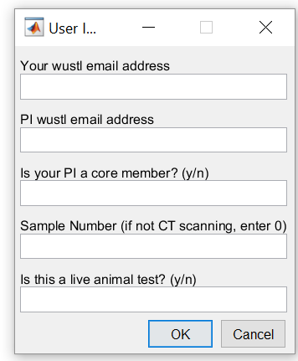

Your wustl key or iLabs email address

Your PI’s wustl key / iLabs email address
y or n on whether or not the financially responsible party is a core memter
3 digit (viva) or 4 digit (micro) sample number
Y or n on if it’s a live animal test

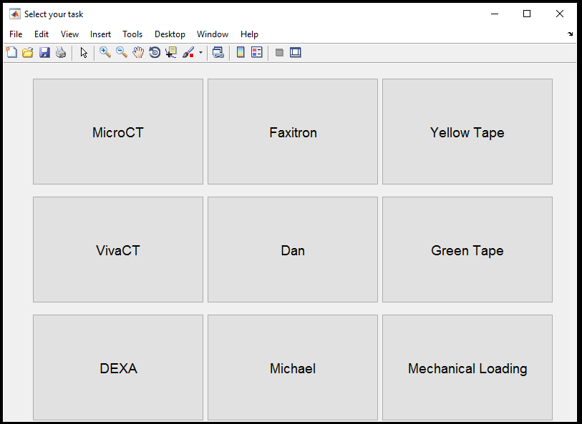

Creating a Control File
When running the uCT 40, you must specify which control file to use for your scans. The control file tells the machine what size tube you are using, which resolution you’re using for that tube, and the energy settings that will be used for the X-ray source. These are all important in obtaining useful information from your scans, and may determine whether you detect a real physiological difference or not. Before you start any experiment, talk to the lab manager about what settings you should use. It varies by the sample type you are scanning. DO NOT JUST USE “YOUR LAB’S” control file! This is wrong. Control files should be set per experiment under the advisement of the lab manager. Very smart people have made very bad mistakes in this area. Be sure to check in!

Preparing Your Samples
Generally speaking, you will dissect out your bones of interest and mount them in a sample tube using 2% agarose. We keep a bottle of agarose in the lab on the shelf immediately to the right when you enter the door; if this is empty, you can make more by mixing 100ml of distilled water per 2g of agarose powder and microwaving until boiling. It is important, however, to make sure that the agarose is cool to the touch before using. If you use hot agarose you can cook your samples, ruining later histology or mechanical testing.
Currently, no tubes may be taken from the imaging lab for any reason without explicit authorization from the lab manager. People have stolen many tubes and two mounting bases, representing thousands of dollars of equipment. They have spoiled it for everyone. Instead, bring your samples to the imaging lab to prepare them for scanning. If you have agarose and the inclination, of course, you may mount your samples in dishes in your lab and then put them in the sample tubes once you arrive.
The size of the tube that you use for your experiment is directly linked to the achievable voxel size of your scans; make sure to discuss what is appropriate for your study with the lab manager at the start of your study. Once a tube size is chosen, you may scan as many bones per measurement as will fit next to each other in the tube. Be sure to line up the part of the bones that you are interested in in the transverse plane. This will allow for the fewest scans/greatest efficiency possible to save you time and money. An example layout may look like the below: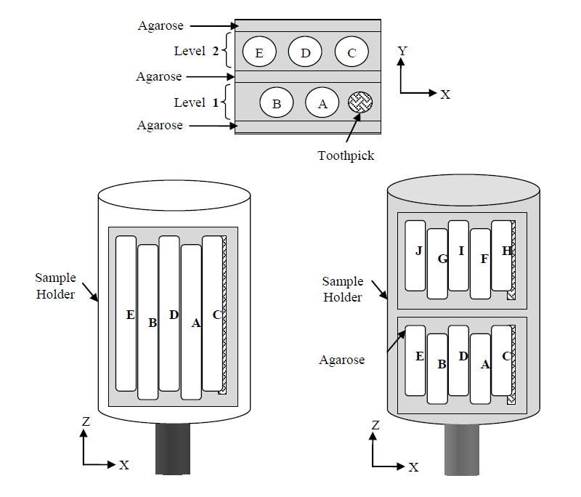
Remember that you can stack layers of bones vertically, so you may have 3 layers of 5 bones for a total of 15 bones in a tube, resulting in needing 3 measurements for that tube with 5 bones in each measurement. It is important that nothing is poking out of the tube, however, as anything taller than the tube will catch on machinery in the scanner and cause problems. Be sure to make sure your tubes are labeled as #1 - # of tubes to keep track of which samples are which.
Once you have mounted your samples in the tubes, it is usually a good idea to fill the tube up with agarose and let it set so nothing moves around.
If agarose isn’t an acceptable mounting method for your samples due to histological needs or other reasons, talk to the lab manager for options available.

Loading the Machine
The uCT 40 scanner has a carousel system that allows for up to 10 tubes to be mounted inside and scanned in batch, allowing you to set up a lot of scans and then walk away. To mount your samples, first place each tube in one of the metal bases. The notch on the bottom of the post must fit on to the crossbar in the base.
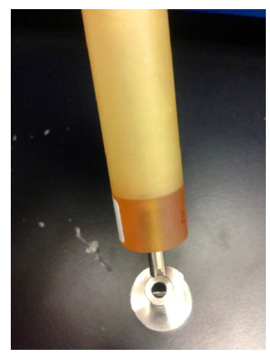
Next, make sure each of your tubes is clearly labeled with numbers 1 - # of tubes, as this will help you keep track of which sample is which. Yes, this is being repeated again. It’s important.
Once labeling is confirmed, place tubes into the carousel so that the flat part of the metal base is in full and direct contact with the octagon in the middle of the carousel. 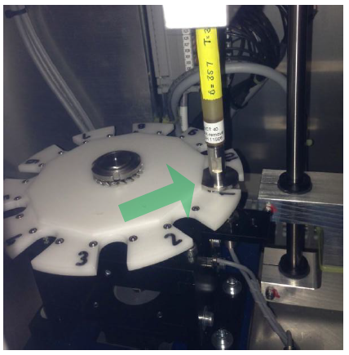
Make sure that you put the tubes in the positions that match what you labeled them.
DO NOT PUT A SINGLE TUBE DIRECTLY IN THE SCANNING STAGE. This can screw up the order of your scans and jumble which scan is which.
If the machine drops tubes while you’re trying to take scout views later, you either didn’t put the flat side of the base against the octagon or you used the wrong size of tube for the control file.
After you load all of your tubes, be sure to close the door tightly and secure it with a bit of tape. The sensor that verifies the door is shut is getting a little tricky; it does indeed close and block any radiation, however.

What You Should See on the Computer Screen
When you move the mouse to wake up the screen (ONLY move the mouse, do not click it, do not press keyboard keys. You should never wake up a computer by pressing things as these clicks and button presses will do things), you should see 4 windows open on the screen.
In the upper left should be the Session Manager window, which is similar to the Start Menu in Windows. You typically should not have to use anything in this window, but know that it should be open. 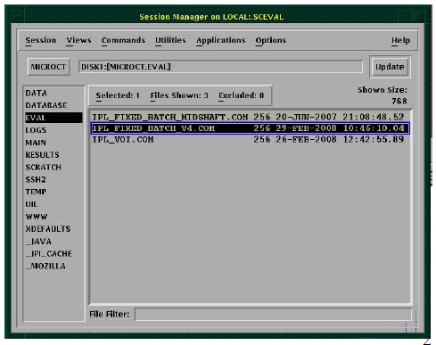

To the right of the session manager should be a DECTerm window; this is a text-based command line, very similar to the commad line in Windows. You will use several basic commands in this window to monitor scans and whether analyses are running correctly. If there is no DECTerm window open, open it by going to Applications in the Session Manager window and clicking DECTerm.
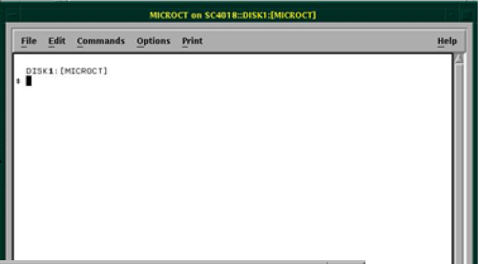

In the lower left of the screen should be the uCT program dock. This dock represents the workflow you’ll be using when making a sample, scanning, and analyzing your data. If it is not open, in the DECTerm window, type “uct” and hit enter. The operator that must be used for this lab is “Silva Lab” (without the quotes).
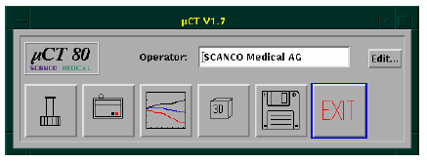
In the lower right will be a rectangle that may or may not have squares in it with program names below it; this is generally equivalent to the Task Bar in Windows. If you minimize a window, left click -> restore here to bring it back up.
If you see a Data Management window open on the screen, DO NOT CLOSE IT. This may destroy someone’s data and/or cost the lab manager hours of time. You may minimize it by clicking on the small dot in the upper right hand corner of the window.
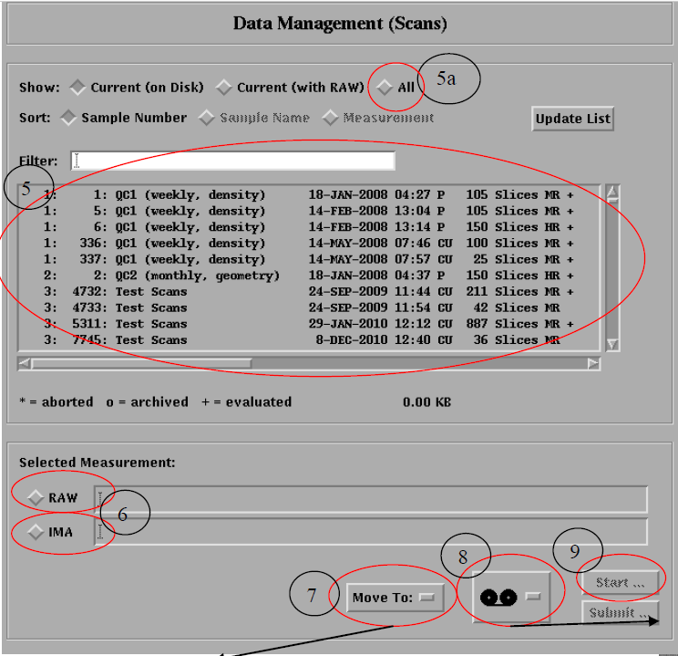

Starting a New Experiment
When starting a new experiment, you must first talk to the lab manager to plan out how your scans will be done. This is very important, as your scan settings may determine if you detect a real physiological difference in your samples, and sometimes if your data are publishable. Some journals are becoming more strict on this front, so make sure to check in with the lab manager on current best practices.
Once you know what you’re going to do for this experiment, you’re ready to create a new sample. To do this, first single click the button on the bottom left

This will launch a program that allows you to create a sample, under which all measurements for your experiment will be stored. The name you give your sample must be formatted thusly:
PILASTNAME_somethingmeaningful_anothermeaningfulthing
Example: Silva_hedgehog_signaling_knockout_oldmice
Note that this must not include any dates! Those are a terrible thing to put in file names that cause all kinds of problems and don’t help to identify the experiment. Name it something that someone, who isn’t you, could understand 5 years from now.
After typing in the name, hit save, and it will automatically generate a 4 digit sample number for you. This is important! Write it down in your lab notebook, not on a napkin or post it note.
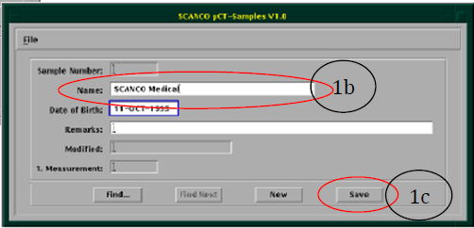

Starting a Set of Scans
To start your set of scans, first mount and load your samples as described above. Once you’ve done so, and the door is closed and secured with tape (due to the tricky sensor), launch the program that is second from the right in the uCT program dock.
This will launch the Tomography program, which controls the scanner.
When prompted, say “Yes” that you would like to do a scan.

The machine will automatically check to see which locations on the carousel are occupied using an optical sensor and highlight the numbers next to the diamonds that have a sample.
If unexpected locations are or are not highlighted, close the tomography program, reposition your samples, and re-open the tomography program.
When prompted, enter the four digit sample number for the study you are performing, and click “Ok.”

Next, it is generally a good idea to make sure that no one else has left unfinished scans in the task list. If they have, it will execute those scans before the ones you set. To do this, click on Task List
And then Clear List and Yes.
Once you have cleared the Task List, it’s time to start adding your scans. This machine operates similarly to how clinical CT is done; first, you take a scout scan that looks much like an X-ray (planar radiograph), then you set a region of interest for the detailed scan based on that scout scan. As a matter of course, always ignore the lower right hand frame of the Tomography program. It rarely shows what it’s supposed to, which is the most recently completed scout view for your sample.
To start your scnas, first click on the diamond next to the carousel position you would like to do first. Then, click on the control file you have previously set up with the lab manager for this experiment. Once both are selected, click Scout View.
The Scout View window will open with the default range of scanning from the control file selected, as well as the default projection angle. You may change these before taking the scout scan to shorten the scout scan and better focus in on your samples. 0mm represents the top of the tube, 80mm the bottom. Once you have set the range for the scout view, click Scout-View
The machine will then grab the tube you had selected and place it in the sample holder and perform the scout scan. This can take a few minutes, as it’s moving a number of things around before taking the scan itself.
Once the scout scan has completed, click on Reference-Line to begin selecting your region of interest for the scan
When you move the cursor over the scout scan itself, green lines will appear. The solid green line indicates where a scan will start, and the dotted green line where it will end. Next to the solid green line is an indicator of where the lines are in the physical space of the scanner. When performing cortical analyses of femurs, use this to establish where the geometric center of the bone(s) are. For tibias, use this to establish the correct difference away from the distal tibio-fibular junction for cortical scans. Whichever sort of scan you are doing, to adjust the size of the green lines, hold down the left shift key and move the mouse up and down to increase or decrease the number of slices that will be included.
Notice that the estimated time of the scan, which is in the lower right of the scout window, does not change with each individual slice. Instead, it increases by “block.” Feel free to maximize the number of slices in each time block when doing scans to ensure you capture a large enough region of interest.
The green lines will lock in place as soon as you press a mouse button. To release them again, click Reference-Line.
Once you have placed the green lines around your region of interest and clicked a mouse button (in that order), press Add Scan. It will inform you when the scan has been added to the Task List.
This scan is now added to the queue. You may do any number of scans per scout view, and as many tubes as the scanner can hold. Once you have added your scans for the current tube, click OK on the Scout-View window. MAKE SURE TO TAKE NOTES on which scan is which! The scanner doesn’t know or care what your animal identifiers are.
And then click on the diamond next to the tube number of interest, click Scout-View again
And continue on as before.
When you have added all of the scans you need to do, click OK on the Scout-View window one last time, then click Task List again. Look at the list of tasks that have been added; do they make sense? Are there more or less than you expect? If so, try to figure out which is which. If you can’t, clear the list and start again. Once you have verified the scans are correct, press Submit Batch Scans in the Task window. This is important! Interactive Task mode will often fail halfway through. Now, you wait! The software will close automatically and run all of your scans in sequence.
Once you have started your scans, DO NOT RESTART THE TOMOGRAPHY PROGRAM. This will cancel your scans, and you’ll have to start over. Also, never open the Tomography program while someone else is running their scans, as it will cancel theirs. This is a primary reason why analysis is not to be one on the scanning computer.
Make sure that you’ve logged in using the electronic system on the Dell computer in the lab. There is also a paper log maintained by BMD, fill that out as well if you can remember.

Analyzing your Scans
Analysis is currently primarily done in the Scanco environment due to its simplicity; efforts are currently being made to put together a unified analysis program via MATLAB that will serve to analyze any CT (including nanoCT) data in the same way, but is currently not available for general use. ONLY do analysis on the designated analysis machine, which is the computer further away from the scanner. You will likely screw up someone else’s scans if you try to use the tomography computer. It’s also slower than a tortoise covered in molasses, so save your sanity.
To get started, click on the box that has three lines that are supposed to look like line graphs. We acknowledge that this makes no sense as you will never generate a line graph via this software, but there it is:
Once open, select a measurement from your sample number you intend to analyze by double clicking. The list is sorted by sample number by default; you can also type numbers or words into the white field in the upper left (and hit enter) to filter the list.
There are many options available to you in this software that you will likely never use; the parts necessary to standard phenotyping and image generation will be outlined here. If you have need of doing a more specialized/custom analysis, speak with the core manager about your options and how to best accomplish your goals. We have a number of different use-case-specific resources available.
First, some orientation.
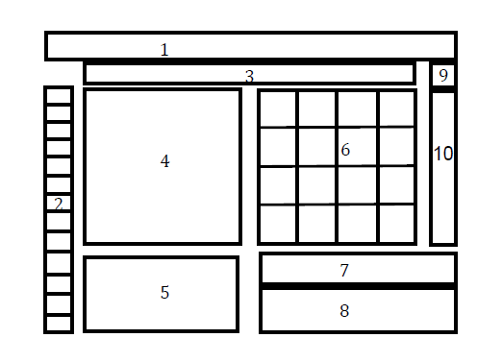
- On the top of the software window are dropdown menus allowing you to access the software’s functionality. Of note is the zoom dropdown, which allows you to zoom by box.
- On the left is a column of buttons used when drawing contours and running analysis. More on these later.
- Labels for the files/slices you’re working with
- The current slice. You do things to this part of the window.
- A grid representing each individual slice in the scan; green boxes indicate drawn lines, yellow/red morphed lines. You can click these to navigate.
- Slices of the scan selected every X number of frames to provide an overview. You can click these to navigate as well.
- Bookkeeping info from the scan you likely won’t use
- Graphical bookkeeping info you likely won’t use
- Density scaling button you likely won’t use
- Color scale-bar selector that you likely won’t use
Cortical Analysis
Cortical analysis is very simple in the Scanco environment. First, open your scan of interest. If you are analyzing multiple bones in the same measurement, which is very common, you MUST WRITE DOWN the order in which you analyze them. When gathering your data, results will be listed in the order that analyses complete. This is true of cancellous analysis as well. This also means that you must wait for one analysis to complete before you start another. Cortical analyses tend to go very quickly, but make sure it’s complete by using que in the DECTerm window.
To complete a cortical analysis:
First, load your measurement.
Next, zoom in on your bone of interest by clicking on the zoom dropdown menu, choosing a magnification number, and clicking around your bone.
Now draw a line in the counterclockwise direction that is fairly close to the surface of the bone on the first slice you’re analyzing. The direction is important! To do this, click on the freehand draw tool in the top position of the left hand column of buttons.
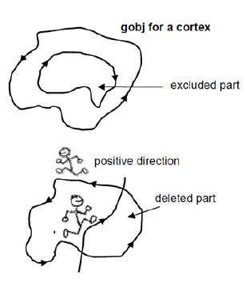
Double click the line you have drawn to bring up the contouring window; for cortical scans, you won’t need to adjust anything here. Double click on the green lines again to adjust the green line to the outside surface of the bone. If any small bubbles form in the line, correct them using the freehand correction tool, which is the second from the top button in the left hand column of buttons. Again, make sure to intersect the green line in a counterclockwise fashion! Double click again to readjust to the surface after cutting out any loops or bubbles.
Once you’re satisfied with your first green line, click Forwards on the Contouring window and then Iterate Forwards to automatically fit contours to the rest of the slices.
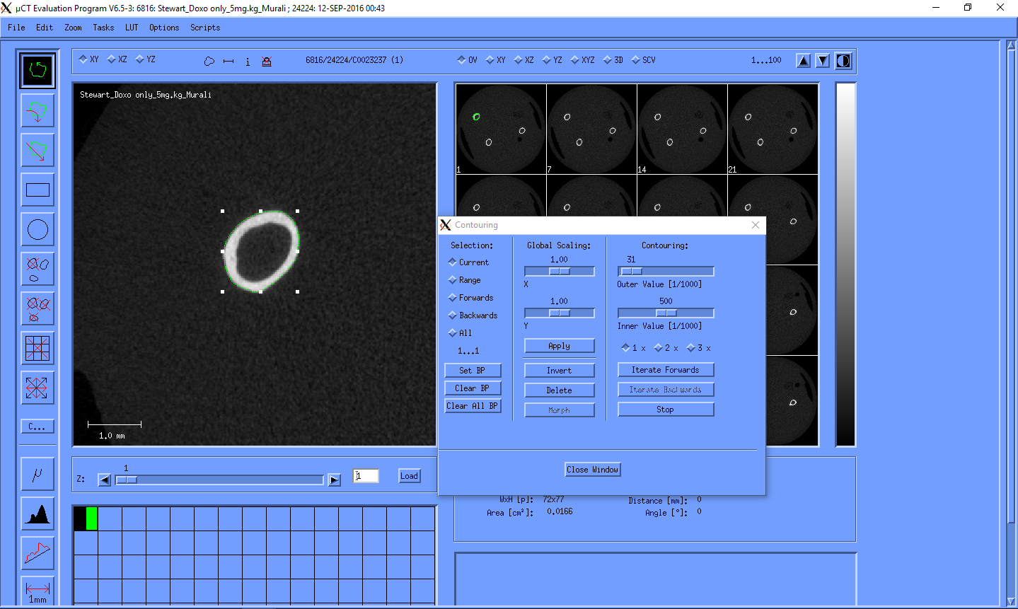
Once the contours have been drawn, hit the T in the lower left had corner of the column on the left. This will bring up the 3D Evaluation pane.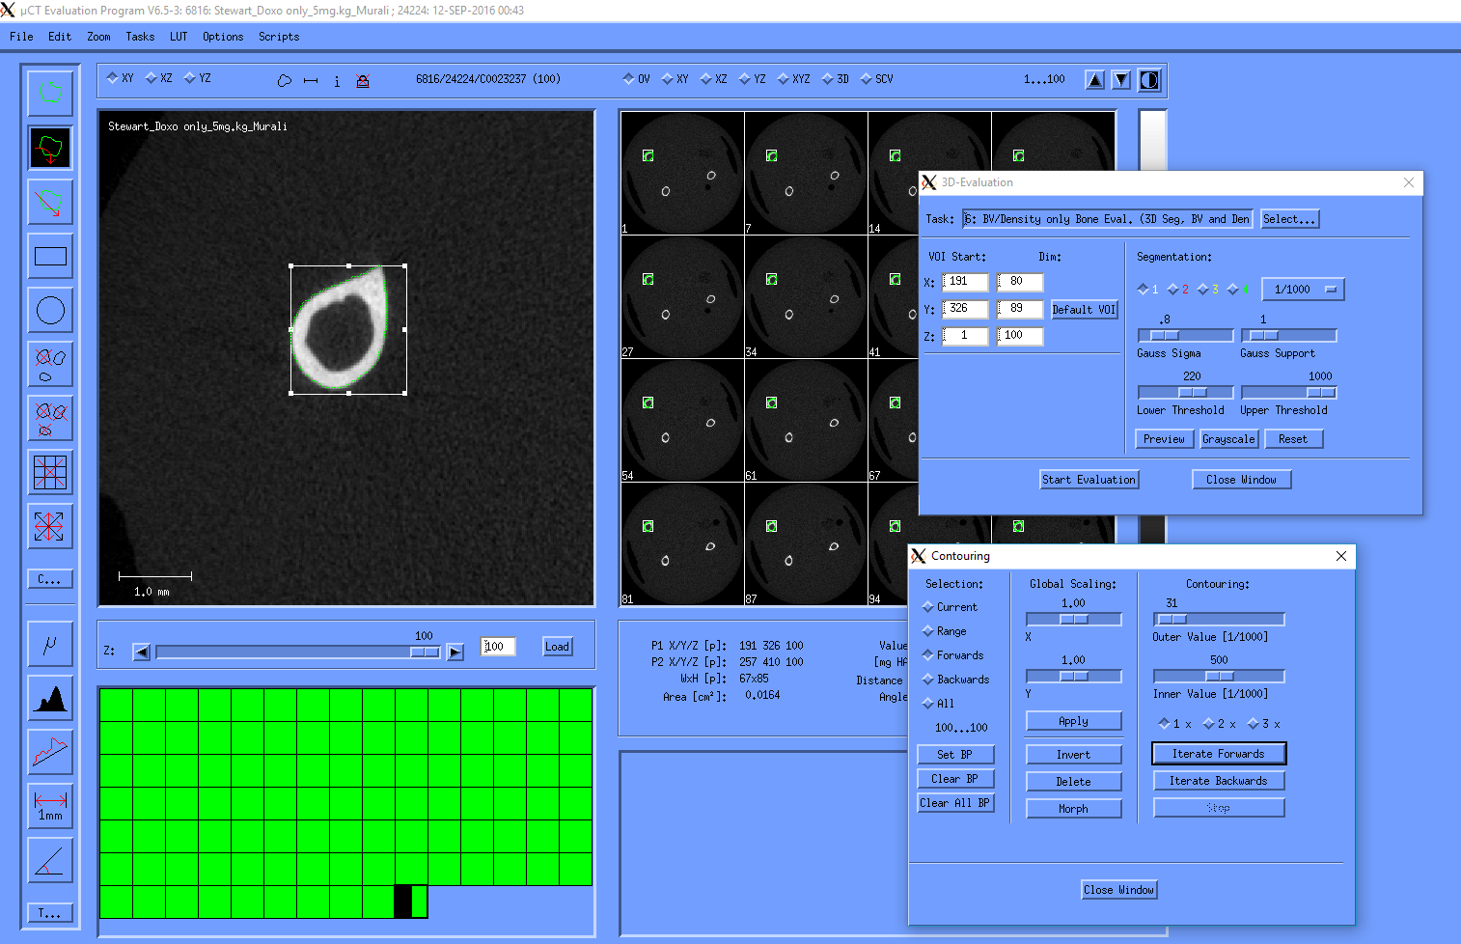
Now hit the Select button on the 3D Evaluation pane and choose task #41. For 99% of analyses, the default settings for this task will work just fine, but to be sure, hit Preview and Grayscale to toggle back and forth between what is being masked and what is not being masked as bone. If too much is covered, raise the lower threshold a bit. If not enough, lower it. For every bone that will be put in to the same statistical analysis, however, the threshold must be the same, except in extreme circumstances (such as comparing 2 week old mice to 6 month for whatever reason).
At this point, relax for a few moments, and wait for the DECTerm window to display that the analysis has completed.
Once it has, hit the topmost box on the left with an X through it 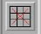 to clear the current set of green lines (say yes when prompted), zoom in on the next bone, and continue on in the same way until you’ve analyzed all of your bones. Note that it is important to press for each successive bone to make sure that your analysis region is snapped to the region bounded by the green lines you drew.
At this point you have generated all of your numerical data; nice work! To gather it into a usable format, use the Dell all-in-one computer in the back corner to run “corticalResultsCompiler” in the folder “MATLAB Tools.” Follow the prompts, and when it finishes you will have a compiled text file containing all of your results for a given sample number. All you have to do is add a column or two for your experimental mouse IDs, relevant genetic info, etc. in Excel or your program of choice.
When you were generating your numbers, 3D images were also generated. These don’t get used terribly often for cortical scans, but have a look at the Generating 3D Images section for more info if you need them.
Cancellous Analysis
Cancellous analysis is very similar to cortical analysis, with two notable exceptions. First, when drawing your green lines, your goal is to have them on the inner border of the shell of the metaphyseal cavity, starting just below the growth plate. Second, threshold selection becomes much more important. As with cortical analysis though, make sure to take notes on the order in which you run your analyses!
To start, load one of your cancellous measurements. Like before, zoom in on your bone of interest. From here, you’ll want to find the first slice on the bone where the growth plate is essentially gone. This is purposely not illustrated here because, to everyone’s dismay, there is no perfect answer to this question. The first time you do this sort of analysis though, make sure to schedule time with the lab manager to step you through it. As it turns out, as verified with internal validation studies, as long as the same person performs this analysis on all the bones used in the same statistical model it works out very reliably.
Once you have determined your starting slice, you have a few options on how to set up your ROI for analysis. The method you’ll most likely want to use is to contour through the metaphyseal cavity away from the growth plate until the cavity contains insignificant trabeculae. Again, this is purposely not pictured, as what this means is a decision for you to make and then consistently implement. The exact number of slices will differ per bone. If this method for some reason doesn’t make sense to use, such as one mouse line having trabeculae that continue all the way down the diaphysis or having “filled in” bones, performing analysis on a set number of slices is typically what is done. For medium resolution scans this usually means 30 slices, for high resolution scans, 60 slices. If you have any questions on which sort of analysis to perform, talk to/email the lab manager.
First, as with cortical analysis, you’ll want to draw contours on your bones to designate a volume of interest to analyze. Because of how the adjusting algorithm works, it’s best to draw the green line in the middle of the shell portion of the first slice you’ve chosen to analyze.
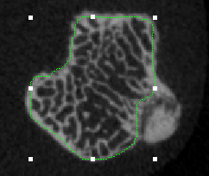
Double click the green line or press the C on the left to bring up the Contouring window again. This time, you’ll want to set the Outer and Inner values to something like the below:
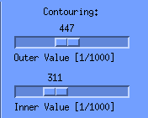
Double click the green line to adjust. If the line “pushes out” too hard, reduce both numbers. If it has trouble staying close to the inner boundary, raise them. The exact numbers can be whatever they need to be to work, as long as the outer value is larger than the inner value. This does not have to be the same between bones, contrary to threshold selection.
Once you find a decent pair of values, iterate forwards or backwards as appropriate. The adjustment may misbehave a little bit while iterating; if so, stop the iterations  and use the freehand adjustment tool to correct it, then continue iterating.
Occasionally, you’ll encounter a bone that just refuses to allow you to use the automatic iteration tool. When this comes up, you’ll want to use the Morph tool. To do so, draw contours by hand intermittently down the volume you want to analyze. Typically this is about every 5 slices, but it may need to be more or less depending on the size and shape of your bone. Once you’ve drawn some green lines, making sure to hit key frames where the shape of the bone starts to change, click on All and Morph in the Contouring window. Interpolated slices will show up as red on the screen in the lower left most of the time, but that doesn’t mean they’re bad. It merely indicates that they’re interpolated.
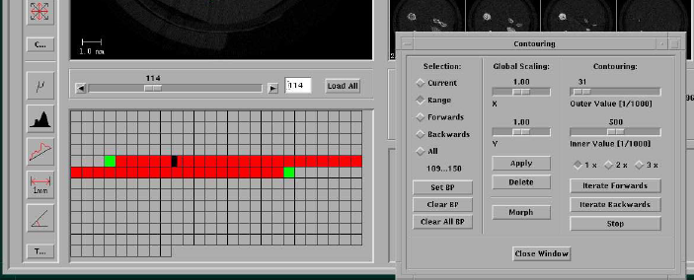
Once you have drawn your contours, open the 3D Evaluation window and select task number 5. Hit the Default VOI button to snap the analysis region to your contours, and then you have two choices to make. The first is how you filter your data, the second being the threshold of intensity you define for bone.
Filtering
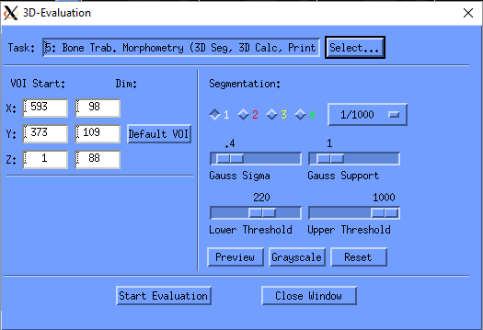
The theoretical foundations of filtering are complicated, but what to do from a practical standpoint is not with our scanners. When you scan at high resolution, you typically don’t need to apply much of a filter to the data for it to work well. We usually recommend using a “light” filter with the Gauss Sigma set at .4 or .8 or something in between and the Gauss Support set at 1. If, for whatever reason, your scans look a bit noisy, 1.2 and 2 respectively usually works well. The scans should update visually as you change these parameters for visual reference.
Thresholding
Setting the threshold is probably the single most important decision you’ll make while performing a cancellous analysis. It determines which pixels in your scan will be counted as bone, which is then used to calculate trabecular thickness, number, bone volume, etc. Take it seriously! If you set it too high, you’ll inappropriately exclude trabeculae, and if you set it too low you’ll accidentally turn some small networks in to large blocks, altering trabecular thickness and related measurements. That being said, it’s fairly straightforward.
Visually inspect the image while changing the lower threshold value; a typical good starting point for cancellous scans is 180. As you move the slider up, you’ll notice less and less bone is segmented. As you move the slider down, more and more is. You’ll want to select a threshold that best balances not overestimating large chunks/speckles of bone, but also doesn’t disconnect continuous structures and lose small portions of trabeculae. It’ll never be perfect, but select a threshold with the best compromise.
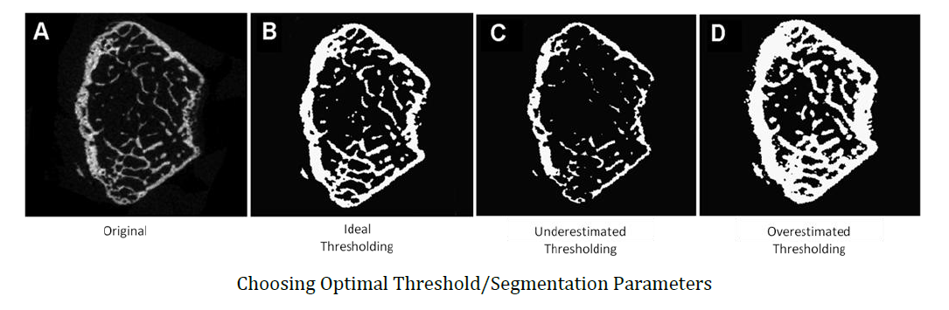

The first time you select a threshold for an experiment it’s a good idea to do it with the guidance of the lab manager. While it’s possible a lab mate can help you well, it’s equally possible they don’t remember how to do it. Talk with the manager.
When selecting the threshold, don’t use only one slice on one scan to determine the threshold. Look at several bones, representing your “best case” and “worst case” scenarios, with several slices near the growth plate and further away. Once you have selected a threshold, you MUST use this same threshold for every bone that will be analyzed in the same statistical model. There are a few cases where exceptions are needed, but these are very uncommon. If you feel one threshold won’t accurately represent reality for all of your scans, be sure to discuss options with the lab manager.
Finishing the Analysis
Once you have set your Gaussian filter values, set the default VOI, and set your threshold, hit “Start Evaluation” as with the cortical analysis. This analysis will take a bit longer to run than cortical analyses typically do; be sure to check whether it has completed by typing que in the DECTerm window before beginning the next analysis. Now, just like with cortical analyses, delete this set of green lines and continue on to the next bone!
Troubleshooting
Note that sometimes the Scanco software just fails, and an analysis will not run properly. When checking if they’re running in the que, sometimes they will show up as analysis_name_00000000_00000000 instead of the appropriate sample and measurement numbers. When that happens, either see the lab manager to terminate the inappropriate analysis, or to do so yourself:
Go to Applications -> Mozilla/netscape
Type the IP address of 10.21.24.204 into the address bar
Use the saved username and password
Click on Batch Queues
Click delete next to the offending analysis and NOTHING ELSE
Close the evaluation program and re-open it and begin again

Generating 3D Images
When you run an analysis using task 41 or 5, it automatically generates a file that can be used to view a 3D image in addition to the numerical data. When viewed, the image will represent explicitly what was analyzed. Sometimes though, you’ll want to create a 3D image that is more comprehensive, such as showing a sagittal view of the trabeculae in the metaphyseal cavity in the context of the shell surrounding it. Both use cases will be described below.
Loading 3D Images from Quantitative Scans
First, open the 3D Viewer software
Navigate to your sample and measurement numbers the same way you would in the Evaluation software. Note that it will only display measurement numbers for which a 3D object exists, so not all of your measurements may show up.
By default, the 3D viewer will only display the most recently created 3D object, which aligns with the most recently completed numerical evaluation. If you wish to display a previous 3D object, go to File, select Open, and follow the arrows below:
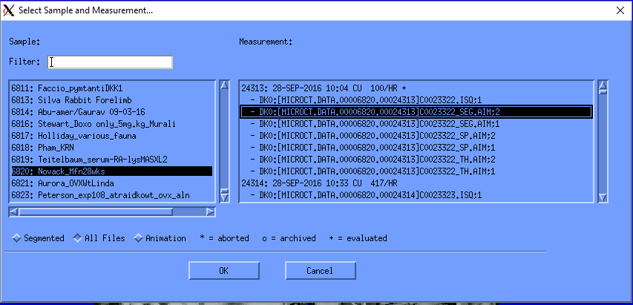
You will select your sample number, click All Files, and then select one of the _SEG.AIM files. The ;# following the file name indicates the order in which the 3D objects were generated (;1 is first, ;2 is second, and so on). This, in addition to interpreting your numerical outcomes, is another reason why it is important to take notes on the order in which you run your analyses.
Once you have found the 3D object of interest, click once anywhere on the blue screen or click Start in the lower left. The software will do a 4-pass render to complete a drawing of the 3D object; however, you can interrupt it at any time by clicking in the blue space in order to rotate or otherwise alter the object. Note that instead of updating the 3D object itself when rotating, the software displays a white rectangular solid representing the volume containing the object and rotates that, then will redraw the 3D object when you release the left mouse button.
To rotate the object, you may left click anywhere in the blue space or on the object and move the mouse around; how you are moving the object will be indicated by the aforementioned white rectangular solid.
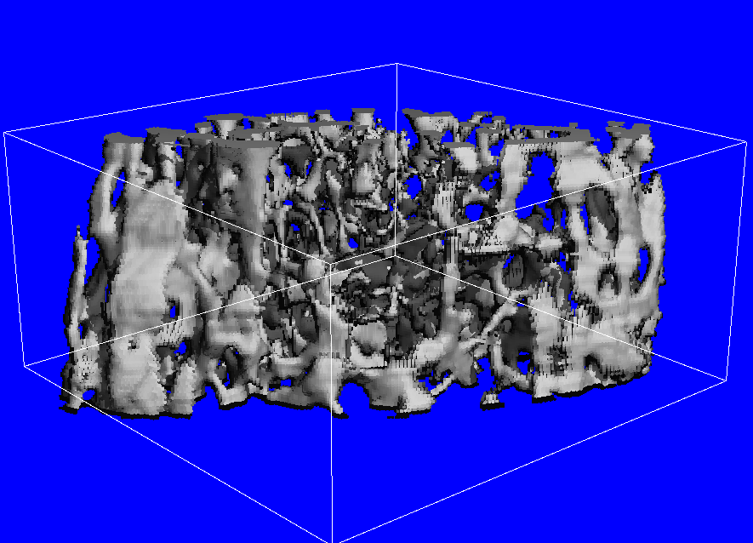
You may also use the sliders on the left of the screen for more precise image adjustment, both to rotate the object and to adjust the lighting if you wish.
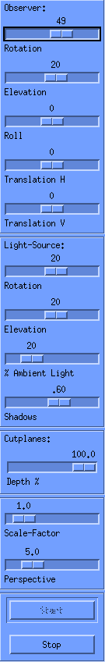
The best way to understand how these work is to simply try moving them and seeing how the image changes. You cannot permanently alter a 3D object, so feel free to play around as much as you like. To reset the object to its original settings, simply close the 3D viewer and re-open the object you’re interested in.
Once you have the object oriented as you’d like, you can also remove portions of the bone to show the inside (often done for cancellous scans) or to reduce the amount of bone shown (often done for cortical). To do this, click subdim on the top dropdown menu and then subdim again (the only option). This will bring up a set of sliders.
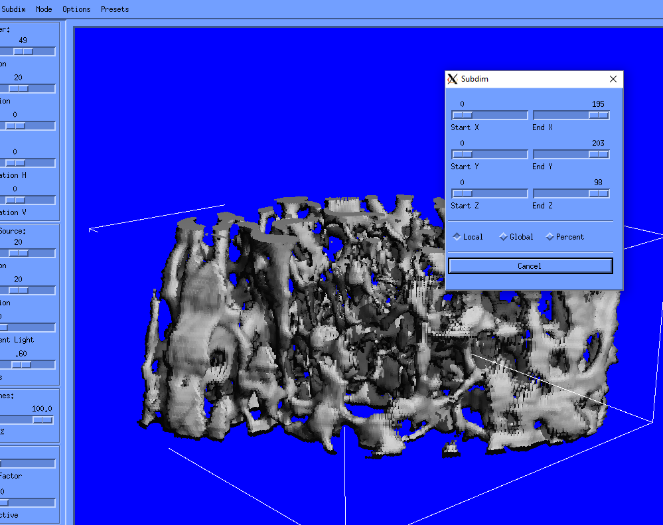
These sliders represent the boundaries of what will be drawn in the X, Y, and Z directions of scanner defined space. To cut your image, move the sliders in your direction of choice and then release; if the image doesn’t update automatically, click in the blue area to refresh. As with the position and lighting of your sample, you cannot permanently change the 3D object, so play around with these until you feel comfortable.
Note that planes cannot be adjusted to the orientation of your bone, which can be a bit frustrating. Usually, though, a decent picture can be obtained if your bones were oriented close to vertically in the tube. If decent images cannot be obtained, check in with the lab manager for other options.
Once you have oriented and cut away bone to your liking, you’ll probably want to save the picture to put in a lab presentation or paper. To do this, in how Scanco has things set up, you must first allow the current rendering to finish all its passes. Then, you can print to a file rather than save. Go to File -> Print, click TIFF and Scratch/Temp, and give the file a name that has meaning to you, then click ok.
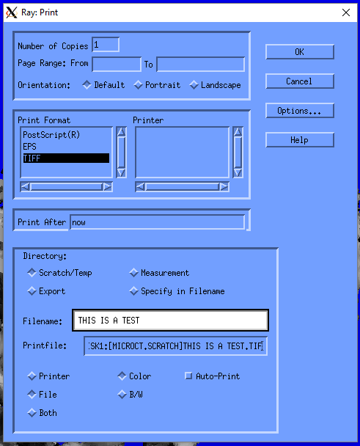
The picture prints very quickly.

Retrieving Data
Retrieving data from the uCT 40 has been greatly simplified recently. To do so, log in to the Dell computer in the corner of the imaging lab. Login with the username microct and the password mousebone4! (NEVER your own domain credentials). To retrieve cortical data, open the MATLAB Tools folder and double click “corticalResultsCompiler.” Follow the prompts, and it will generate a text file in the folder you have indicated that can be opened in Excel or your favorite text editor. To gather cancellous results data, run “trabecularResultsCompiler” in the same way. If you see a line containing all zeros in your results file, that almost always means that you have forgotten to press Default VOI before running your analysis. Go back and re-run those samples to generate values, making sure to press that button!
Retrieve TIF images
Getting TIFs is slightly more complicated. To do so, open the program called FileZilla. This is an FTP client, which operates much the same way File Explorer does on Windows, but it can communicate with the scanning computers. Once open, click the small icon above the word “Host” in the upper left and then click on the scanner of interest (Viva or Micro).
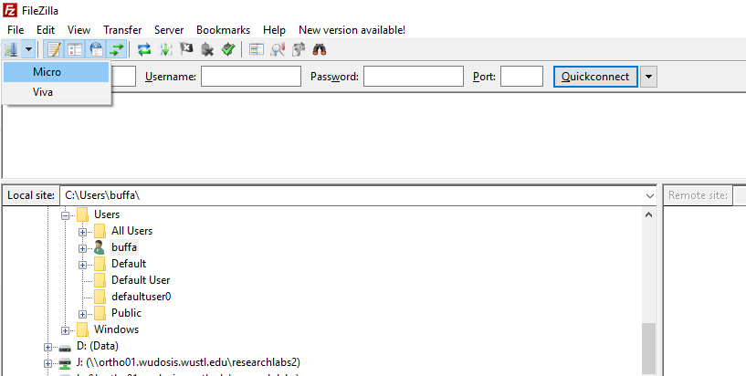
After a moment a connection will be established with the scanning computer and the box in the lower right will be populated by a list of folders and files. Double click on Scratch (it will take a few moments to load given the large number of files usually in this folder).
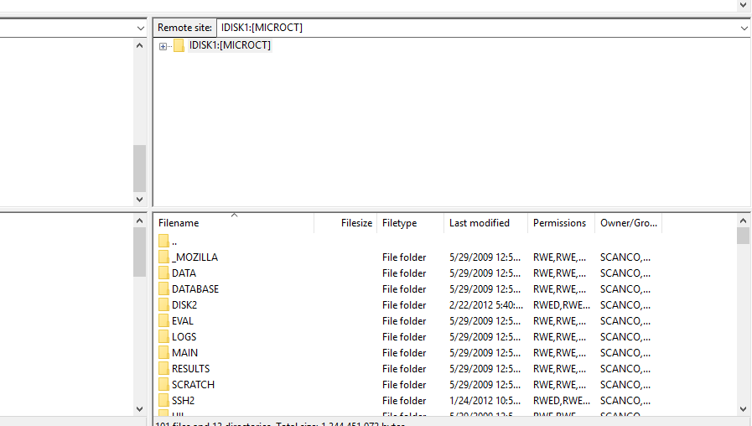
Now you can drag and drop your pictures to the desktop with one caveat; ensure that the transfer type is set to binary first
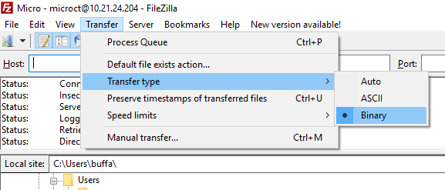
Once you’ve drug your pictures on to the desktop, you can transfer them to a flash drive or email them to yourself, whatever’s easier.

Loading and Using Older Contours
Loading and using previously drawn contours in Scanco’s software isn’t as easy as it should be. To do so, bear a few things in mind:
-Your contours are saved as .gobj files in the order that you saved them. This is completely independent of running analyses, especially for the convoluted workflows some labs have opted to use.
-An analysis task will never run on a .gobj file that doesn’t have the default file name. If you saved a .gobj as “my_contour.gobj;3” you will need to rename it to the default name for it to work. Best practice is not to do that, but instead record which .gobj;# corresponds to which set of lines.
That said, to use a previously drawn and saved contour:
-Load the appropriate .gobj file by going to file -> load gobj
-Once the contour is loaded, open the contouring menu by hitting C on the left and hit “apply”
-Select your analysis task, hit Default VOI, and start. When prompted, save the contours. If you aren’t prompted to save, you didn’t do it properly and the task will re-run on the current most recent contour.
Continue as often as needed.

